Animesh Parab T2-T21 88

**ASSIGNMENT 2 CLOUD9**

**AIM-** To create aws Cloud9 IDE account and execute python application development.

**Theory-**Cloud9 IDE is an Online IDE, published as open source from version 2.0, until version 3.0. It supports multiple programming languages, including C, C++, PHP, Ruby, Perl, Python, JavaScript with Node.js, and Go. It is written almost entirely in JavaScript, and uses Node.js on the back-end.

***STEPS-***

LOG IN TO YOUR AWS ACCOUNT,

SEARCH FOR CLOUD 9 IN THE SEARCH BAR

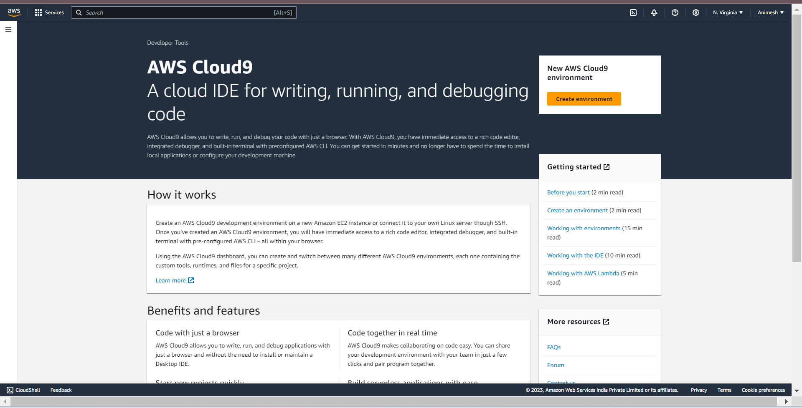

CLICK ON CREATE ENVIRONMENT,

NAME THE ENVIRONMENT

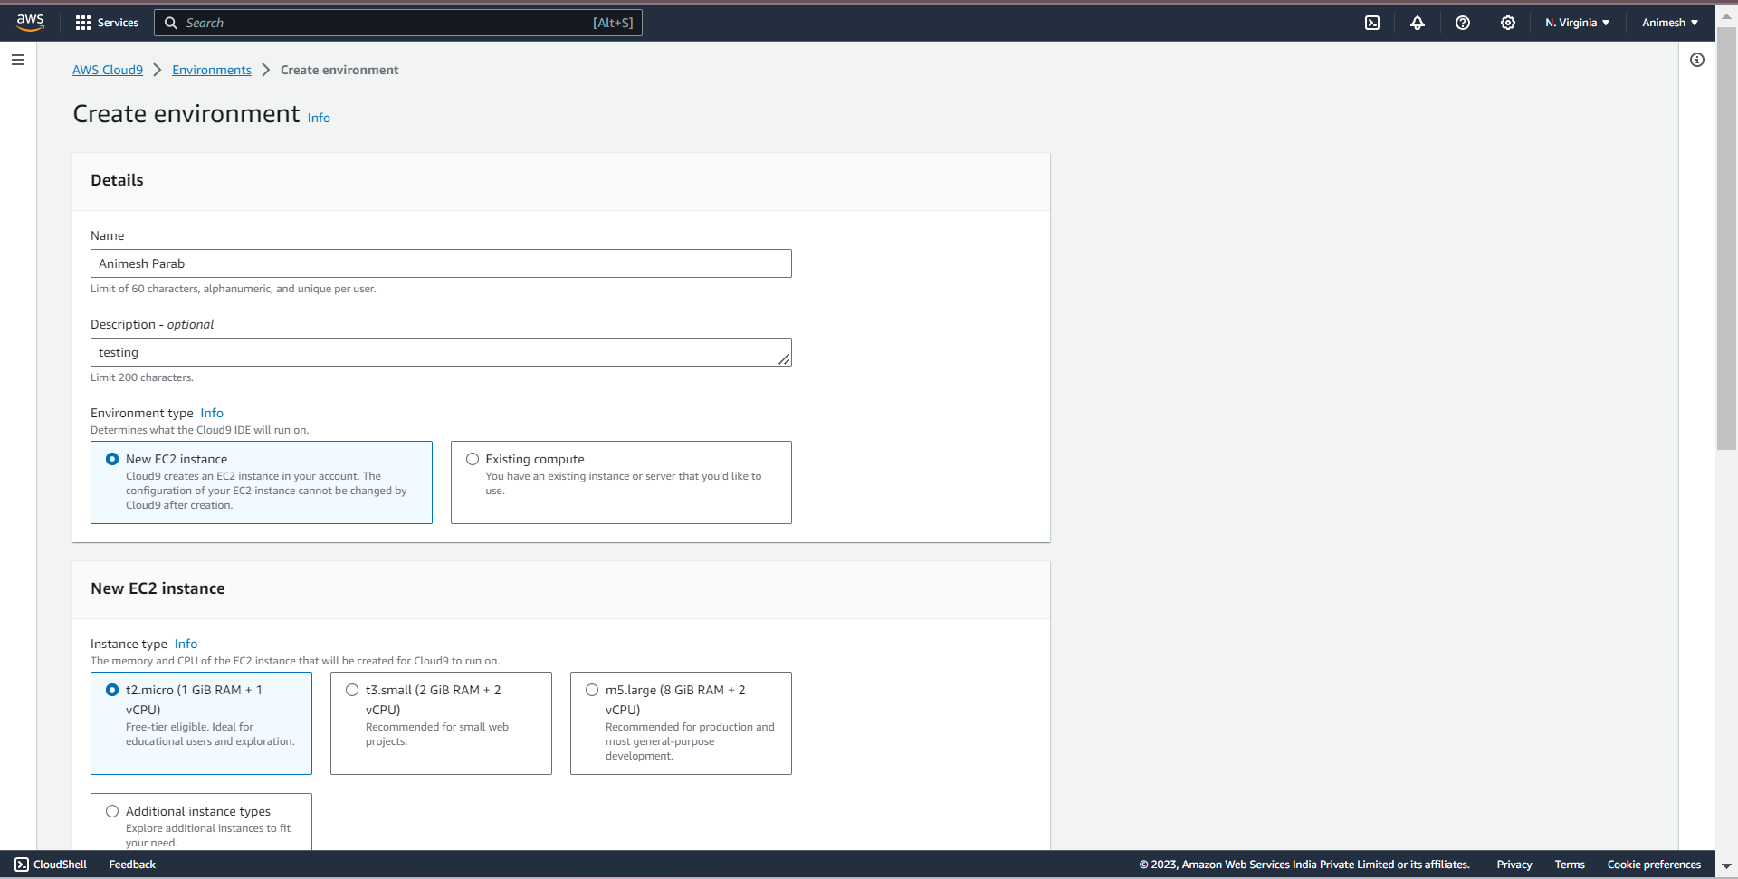

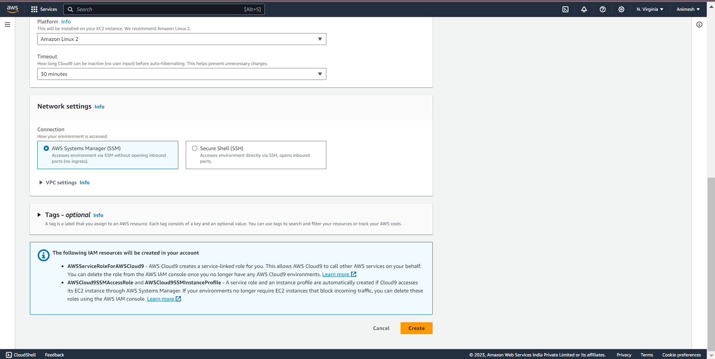

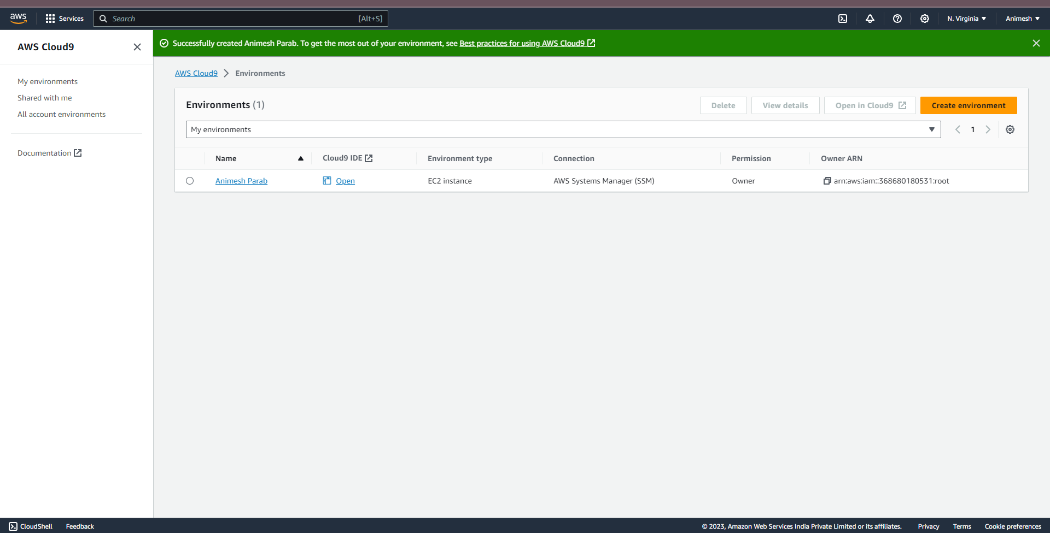

Now select any coding language and perform any operation via a code. Shown below

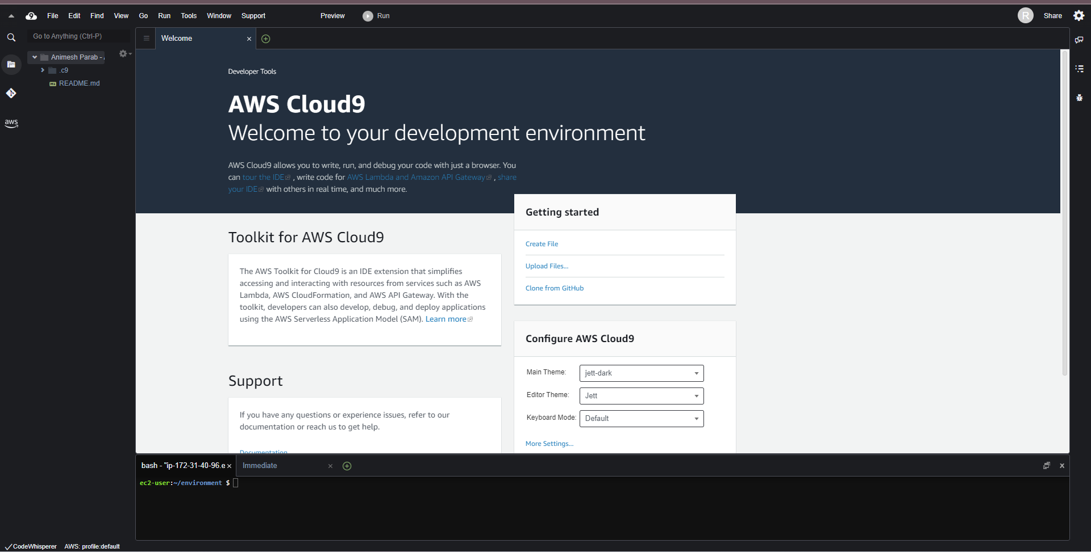

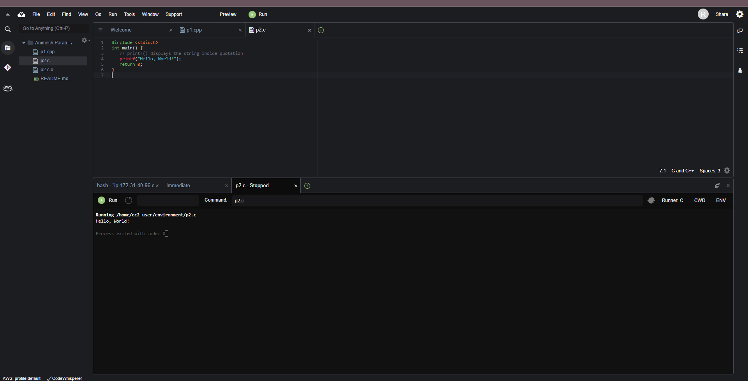

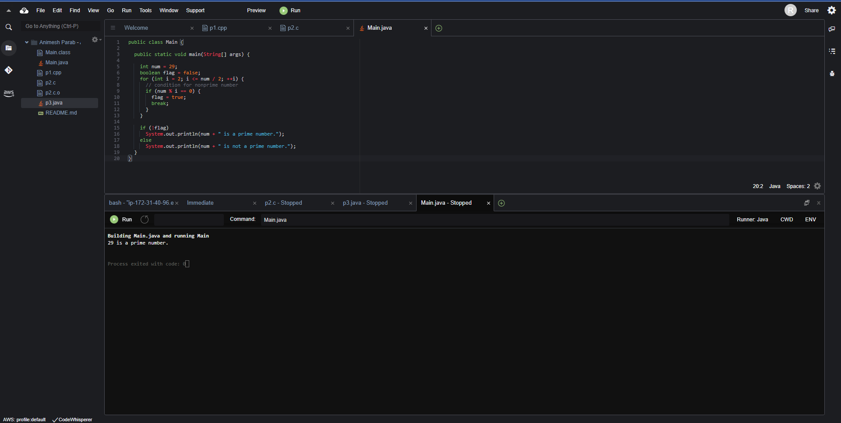

***Conclusion –*** Hence learned and implemented steps to Create an Cloud9 environment